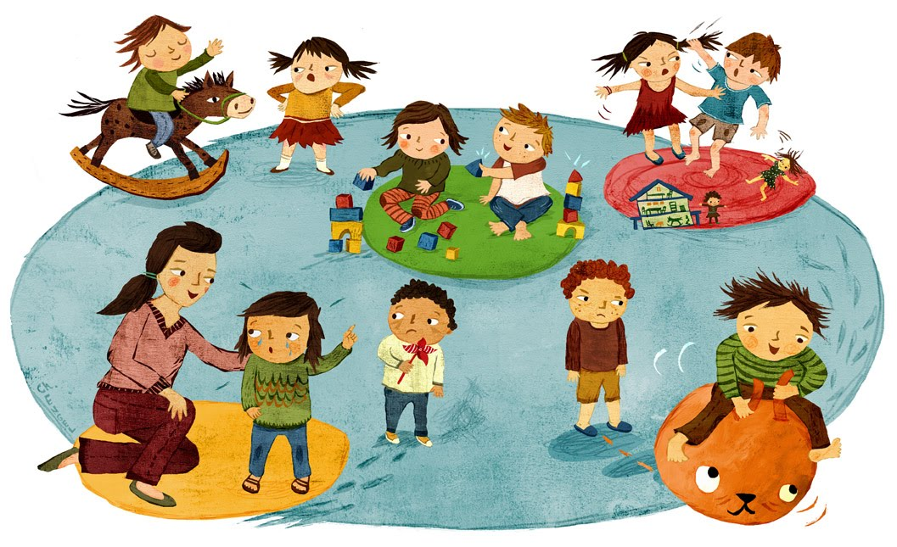

* CHILDREN AGE OF ADMISSION IS 1 YEAR AND SIX MONTHS TO 6 YEARS OLD.
* CHILD TO BE UP TO DATE WITH VACCINATION CARD.
* PARENTS TO FILL UP THE FORMS AND FOLLOW OUR RULES AND REGUALTIONS.
* PLEASE REPORT WHEN CHILD IS SICK .
* SICK CHILDREN MUST BE KEPT AT HOME WITH DRS INSTRUCTION, AND WHEN A CHILD IS
* FEELING MUCH BETTER PLEASE PACK THEIR MEDICATION TO FINSIH THE COURSE.
* ALL CHILDREN TO REPORT TO SCHOOL BY 8AM EVERY DAY.
* FULL UNIFORM MONDAY /WEDNESDAY/FRIDAY
* PLEASE NOTIFY THE TEACHER WHEN YOU REQEST SOMEONE TO PICK UP THE CHILD.
* ALL VISITORS TO REPORT TO OFFICE
* NO COLD DRINK /SWEETS/CHOCOLATE/FAT CAKES /SIMBA CHIPS WILL BE ALLOWED IN OUR PREMISES
* THINGS TO BRING ALONG WATER BOTTLE /FRUITS /DRY FRUITS